LEARNING AREA3 TAKING CARE OF MYSELF FOR PROPER GROWTH AND DEVELOPMENT
(HEALTH HABITS) TERM I 2026

LEARNING AREA3 TAKING CARE OF MYSELF FOR PROPER GROWTH AND DEVELOPMENT
(HEALTH HABITS) TERM I
WEEK1-3
- Caring for my eyes
Suggested activities
- Naming body parts orally e.g. nose, eyes, fingers, etc.
- Tracing body parts e.g. nose ,fingers
- Shading body parts
- pasting
- sand play
- matching the same body parts
- reciting rhymes about body parts
“My body, hohoo mubiri gwange Gulina amaso
Abasomesa bagayita eyes”
Activity
Match the same body parts

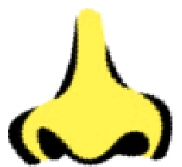
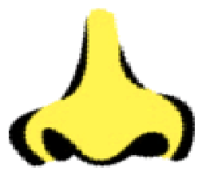
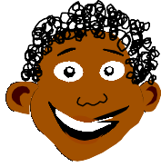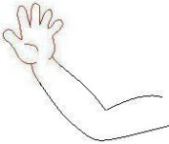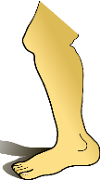

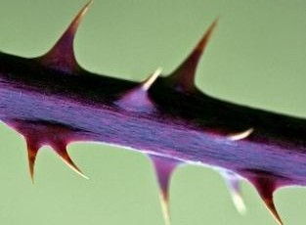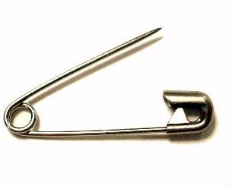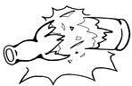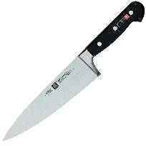WEEK4-5
Suggested activities
- Naming body parts orally e.g. head, hands, etc.
- Naming things that harmour bodies e.g.Pins, fire ,hot water, etc.
- Tracing pictures of the things that harm the body e.g.
- Matching the same
- Practicing was hing the body
- Naming orally, drawing,shading,tracing things that are used to clean the body e.g. water, soap, etc.

Activity
Things used to clean our body
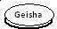 |  | 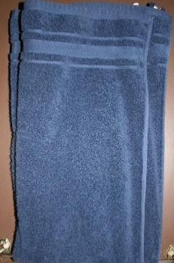

Dangerous objects.

WEEK 6-7
- Knowing how to clean the environment orally e.g. broom, dustbin, etc.
- Shading pictures
- Drawing pictures e.g.
- Pasting pictures
- Matching to the same
- Roleplaying
- Storytelling
- Reciting rhymes

WEEK8-9
- Exploring and knowing my immediate environment
Suggested developmental activities
- Naming things orally
- Reciting rhymes
- Imitating animals
- Tracing pictures
- Roleplaying
- Drawing pictures
- Matching to the same
- Grouping
- Shading pictures

